AI Futures

AI Futures

Activity Overview
Students reflect on the Fair AI Guidelines they’ve built and imagine through creative projects a future where their principles become reality.
Learning Objective  Students will demonstrate their understanding of AI fairness principles by creating imaginative representations of a future where AI follows their guidelines. | Standards & Competencies  - 1a (Recognize AI Systems)  - 2b (Examine AI use and outputs)  - 3a: (Lead and collaborate on projects)  - CCSS.ELA.SL.4.1: Engage effectively in collaborative discussions
Materials  - Imagining Fair AI Choice Board  - Creative materials (paper, markers, building blocks, etc)  - Class poster with Fair AI Guidelines | Preparation  - Print Imagine Fair AI Choice Boards for each student.  - Set up creative materials for choice board activities.  - Display completed Fair AI Guidelines poster.

Launch (2-3 minutes)
Slide | Exploration Guide
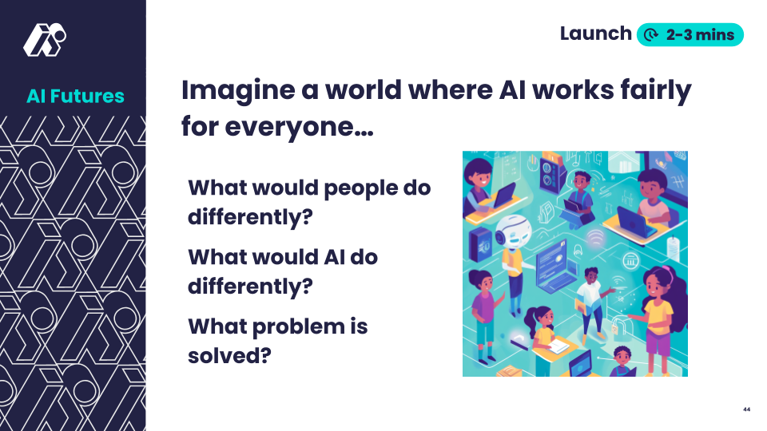 | [Post class-created guidelines]  Say: “In previous Explorations we made rules about how AI should behave and what people should do to make it better. Now let’s imagine a world that follows those rules.”  Students review each guideline statement and commitment.  Ask:  - “What would change in the world if everyone followed our Fair AI beliefs?”  - “What would people do differently? What would AI do differently?”  Look For:  - “AI would work for everyone—even if they have slower internet or a different language.”  - “People would be careful about sharing their info.”  - “AI would ask permission before using our stuff.”
💡Teaching Tip: Use a think-pair-share to give processing time. Use sentence starters:
- "If AI followed our rules, ______ would happen."
- "People would feel safer because ______."

Play (10-12 minutes)
Slide | Exploration Guide
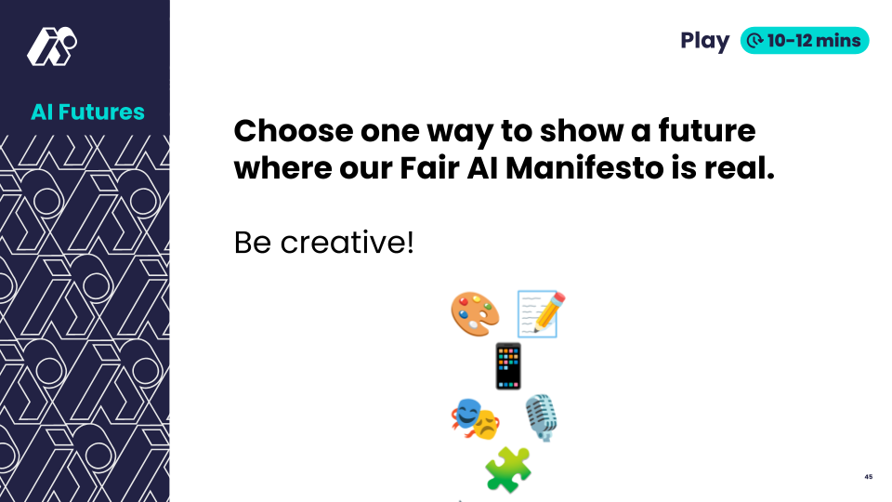 | Say: "Now it’s time to imagine a future where our Fair AI principles come to life. You’ll choose one of the options on the Imagining Fair AI Choice Board and create something that shows what that future looks like."  Distribute Imagining AI Futures choice boards.  Say: "Work with your partner or group to bring your Fair AI future to life. You’ll have 10-12 minutes to create your project. Remember to explain how your future connects to one of the Fair AI statements."  Alone or in small groups, students create a representation of an AI future in which their guidelines are followed.  Allow each group to share their creation with the class.  Look For:  - "Our future shows AI asking permission before using data."  - "This future shows AI working well even with slow internet."  - "AI in our future respects everyone’s privacy."  Common Student Misconceptions:  - "Technology problems can't be fixed"  - Response: "How might redesigning this AI make it more fair?"
💡Teaching Tip: Allow students to choose based on their strengths (art, writing, performance, etc.), Encourage variety in final presentations—offer a mini gallery walk to celebrate creativity. Pair students for collaborative options where possible.

Land (5-7 minutes)
Slide | Exploration Guide
 | Say: “You just imagined amazing futures—ones where AI is used with care, respect, and fairness. This is your vision of what’s possible. Let’s finish by thinking about how we can bring this future closer.”  Ask:  - “What did you notice in each other’s work that made you feel hopeful?”  - “What can YOU do to help make this future real?”  Students come up with a final wrap-up statement about fair AI.  Look For:  - “AI can be great—but only if people use it fairly.”  - “I can help others think before they share things with AI.”  - “We believe in a future where AI is fair, respectful, and shared by everyone, and where people use it with care and kindness.”
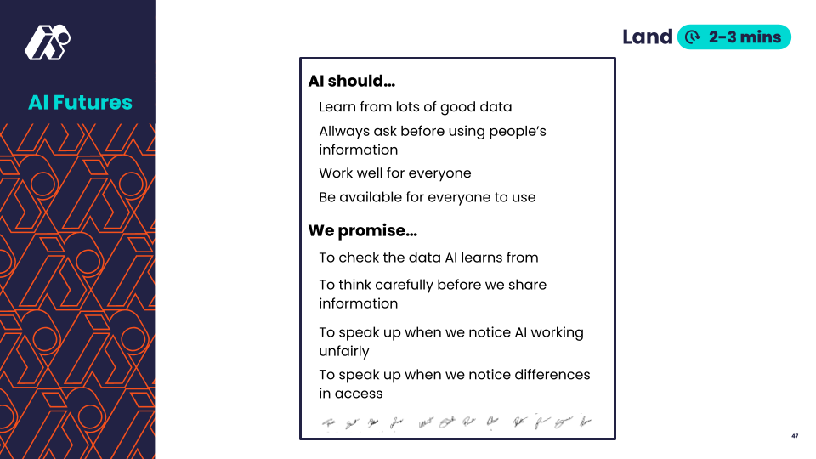 | [Display finalized guidelines with signature space]  Say: "Let's sign our Fair AI Guidelines and share what we've learned with others."  Students sign guidelines. Students propose ways to share with school community. Students reflect on personal commitments to AI Fairness.  Look For:  - "We could present it at assembly"  - "Let's make copies for other classes"  - "I'll tell my family about these rules"  - "We should post it where everyone can see it"
💡Teaching Tip: Create structured sharing circle. Host a mini “gallery walk” or performance showcase.

